**三、计算方式及数据获取**

3.1 动量因子

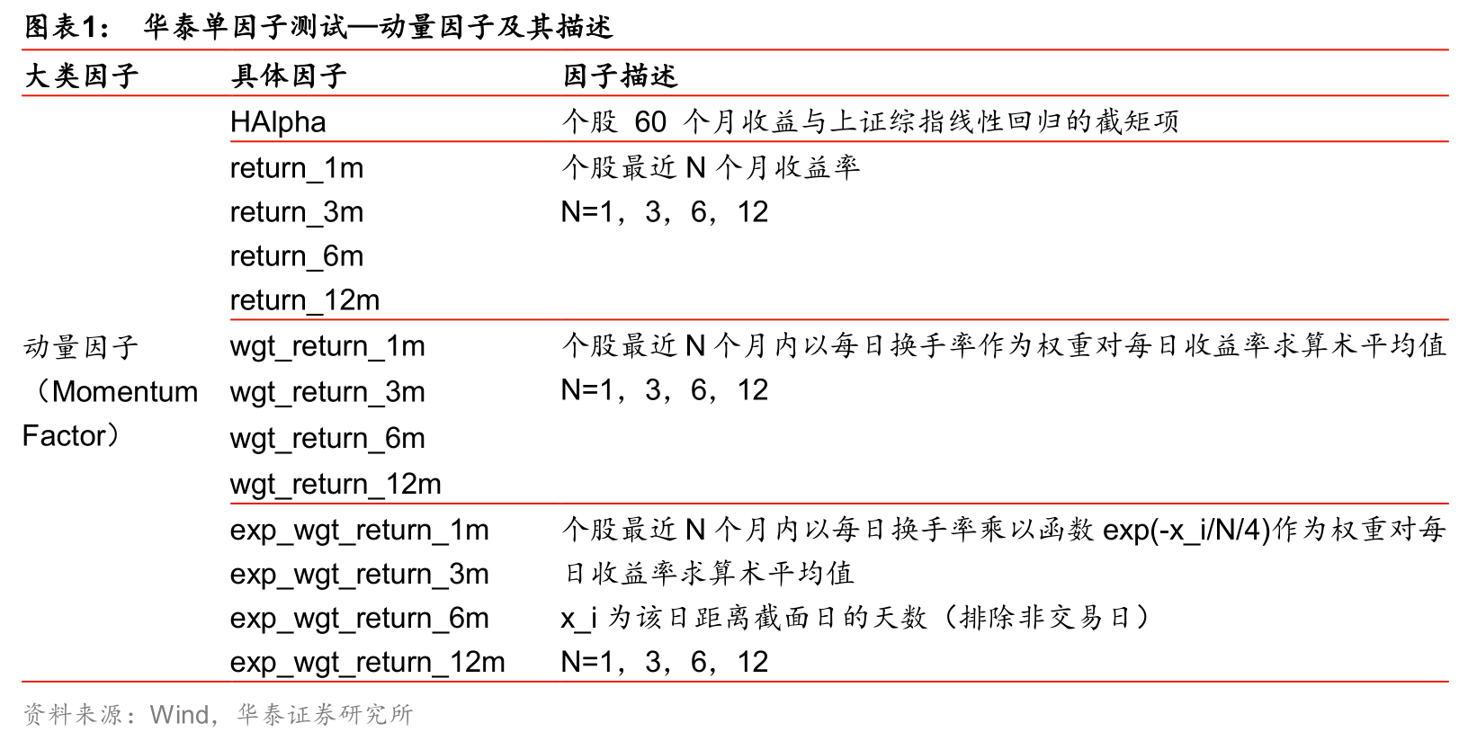

已经在factor.py里有完整调用代码

*# 个股最近N月收益率 写好了 大概调用方式*

df_monthly = pro.monthly(ts_code=self.code, start_date=**'20100101'**, end_date=**'20191231'**,fields=**'ts_code,trade_date,close,pre_close,pct_chg'**)

df_monthly[‘pct_chg’] #一个月

df_monthly[‘close’].pct_change(periods=3); #三个月

df_monthly[‘close’].pct_change(periods=6); #六个月

df_monthly[‘close’].pct_change(periods=12); #十二个月

*# 个股最近N月内以当月算数平均每日换手率为权重的收益率 写好了*

df_monthly = pro.monthly(ts_code=self.code, start_date=**'20100101'**, end_date=**'20191231'**,fields=**'ts_code,trade_date,close,pre_close,pct_chg'**)

df_daily_basic=pro.daily_basic(ts_code=self.code,start_date=**'20100101'**, end_date=**'20191231'**,fields=**'ts_code,trade_date,turnover_rate'**)

mon_avg_turnover=data_basic_daily.resample(**'M'**,on=**'trade_date'**).mean();

df_monthly[‘pct_chg’]/mon_avg_turnover #一个月

df_monthly[‘close’].pct_change(periods=3) /mon_avg_turnover; #三个月

df_monthly[‘close’].pct_change(periods=6) /mon_avg_turnover; #六个月

df_monthly[‘close’].pct_change(periods=12) /mon_avg_turnover; #十二个月

3.2 换手率因子

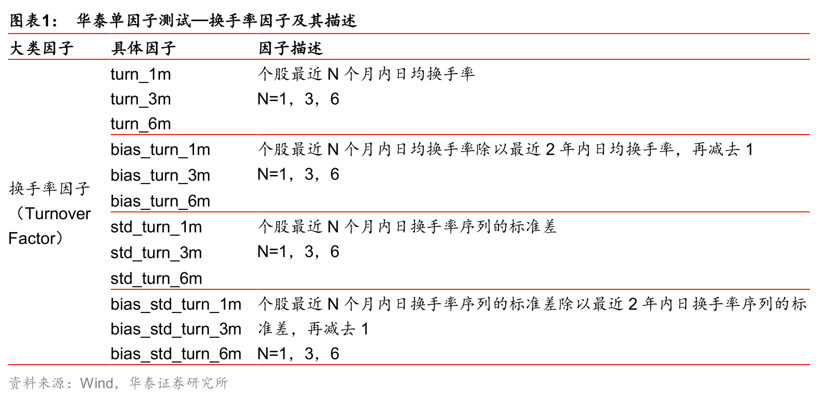

已经在factor.py里有完整调用代码

# 个股最近N个月日均换手率

df_daily_basic=pro.daily_basic(ts_code=self.code,start_date=**'20100101'**, end_date=**'20191231'**,fields=**'ts_code,trade_date,turnover_rate'**)

mon_avg_turnover=data_basic_daily.resample(**'M'**,on=**'trade_date'**).mean();

turn_1m = pd.DataFrame({**'month'**:mon_avg_turnover[**'trade_date'**],  
 i:mon_avg_turnover[**'turnover_rate'**]});  
turn_3m = pd.DataFrame({**'month'**: mon_avg_turnover[**'trade_date'**],  
 i: mon_avg_turnover[**'turnover_rate'**].pct_change(periods=3)});  
turn_6m = pd.DataFrame({**'month'**: mon_avg_turnover[**'trade_date'**],  
 i: mon_avg_turnover[**'turnover_rate'**].pct_change(periods=6)});

# 个股最近N个月日均换手率除以最近1年内日均换手率

df_daily_basic=pro.daily_basic(ts_code=self.code,start_date=**'20100101'**, end_date=**'20191231'**,fields=**'ts_code,trade_date,turnover_rate'**)

mon_avg_turnover=data_basic_daily.resample(**'M'**,on=**'trade_date'**).mean();

year_avg_turnover=data_basic_daily.resample(**'Y'**,on=**'trade_date'**).mean(); #最近一年内日均换手率

wgt_turn_1m = pd.DataFrame({**'month'**:mon_avg_turnover[**'trade_date'**],  
 i:mon_avg_turnover[**'turnover_rate'**]/ year_avg_turnover});  
wgt_turn_3m = pd.DataFrame({**'month'**: mon_avg_turnover[**'trade_date'**],  
 i: mon_avg_turnover[**'turnover_rate'**].pct_change(periods=3)/ year_avg_turnover });  
wgt_turn_6m = pd.DataFrame({**'month'**: mon_avg_turnover[**'trade_date'**],  
 i: mon_avg_turnover[**'turnover_rate'**].pct_change(periods=6)}/ year_avg_turnover);

3.3 波动率因子

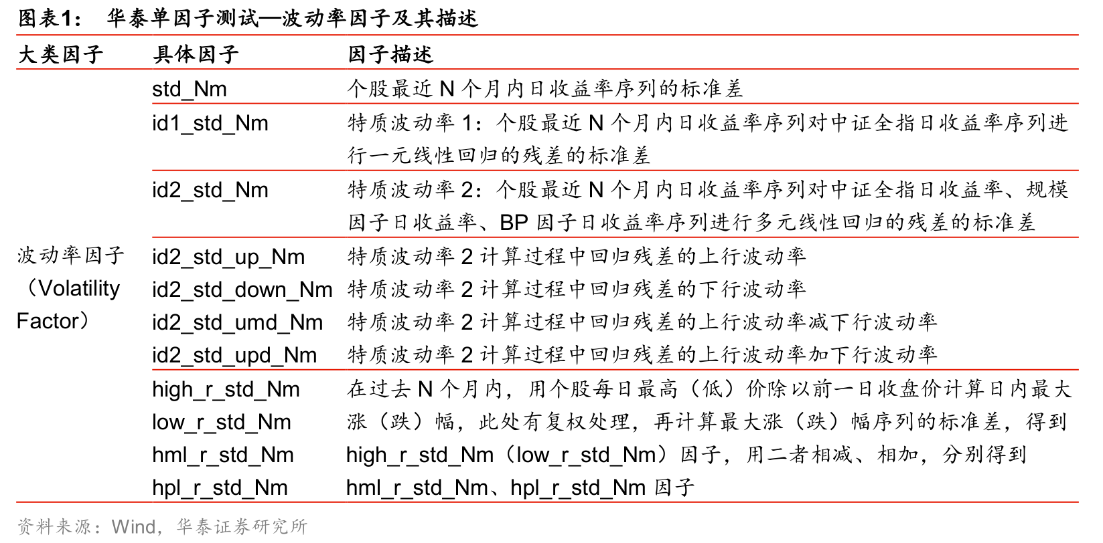

这部分还没有写成.py 直接找调用接口

# 个股最近N个月内日收益率标准差

df_daily= pro.daily(ts_code=self.code, start_date=**'20100101'**, end_date=**'20191231'**);

daily_return = df.daily[‘close’]-df.daily[‘pre_close];

daily return_1m = daily_return.resample('M',on='trade_date').mean();

daily return_3m = daily_return.resample('M',on='trade_date').mean().pct_change(periods=3);

daily return_6m = daily_return.resample('M',on='trade_date').mean().pct_change(periods=6);

daily return_12m = daily_return.resample('M',on='trade_date').mean().pct_change(periods=12);

……对这些daily_return_NM序列求标准差（交给周老师了）

# 特质波动率1：个股最近N个月内日收益率对沪深300收益率序列进行一元线性回归的残差的标准差

df_daily= pro.daily(ts_code=self.code, start_date='20100101', end_date='20191231');

daily_return = df.daily[‘close’]-df.daily[‘pre_close];

daily return_1m = daily_return.resample('M',on='trade_date').mean();

daily return_3m = daily_return.resample('M',on='trade_date').mean().pct_change(periods=3);

daily return_6m = daily_return.resample('M',on='trade_date').mean().pct_change(periods=6);

daily return_12m = daily_return.resample('M',on='trade_date').mean().pct_change(periods=12);

index = pro.index_daily(ts_code = ‘000300’)

index_return = index[‘close’]-index[‘pre_close’];

index_return_1m = daily_return.resample('M',on='trade_date').mean();

index_return_3m = daily_return.resample('M',on='trade_date').mean().pct_change(periods=3);

index_return_6m = daily_return.resample('M',on='trade_date').mean().pct_change(periods=6);

index_return_12m = daily_return.resample('M',on='trade_date').mean().pct_change(periods=12);

……daily_return_NM对index_return_NM进行一元线性回归算残差 再算残差的标准差